Dry distillation is Also known as destructive distillation. Dry distillation of which of the following compound yields Methanal?
A. Methanol
B. Calcium formate
C. Calcium acetate
D. Both B and C
ANSWER: B
Formalin is ____.
A. $80\% HCHO, 8\% CH_{3}OH and 12\% H_{2}O$B. $60\% HCHO, 8\% CH_{3}OH and 32\% H_{2}O$
C. $40\% HCHO, 8\% CH_{3}OH and 52\% H_{2}O$
D. $20\% HCHO, 8\% CH_{3}OH and 72\% H_{2}O$
ANSWER: C
It is used in laboratory for catalytic oxidation of methanol.
A. Pt-Asbestos at $300℃$
B. $FeO, MoO_{2}$ at $500℃$
C. $Na_{2}Cr_{2}O_{7}, { H}_{2}SO_{4}$
D. $PdCl_{2},CuCl_{2}, H_{2}O$
ANSWER: A
It is used in industry for catalytic oxidation of Ethanol.
A. Pt-Asbestos at $300℃$
B. $FeO, MoO_{2}$ at $500℃$
C. $Na_{2}Cr_{2}O_{7}, { H}_{2}SO_{4}$
D. $PdCl_{2},CuCl_{2}, H_{2}O$
ANSWER: B
Nucleophilic addition reactions are expected to be in _______.
A. $C=C$
B. $C≡C$
C. $C=O$
D. $C≡N$
E. Both C and D
F. Both A and B
ANSWER: E
Which of the following methods cannot produce aldehydes?
A. Oxidation of primary alcohols
B. Dehydrogenation of secondary alcohols
C. Ozonolysis of alkenes
D. Hydration of ethyne with acid
ANSWER: B
Which of the following method cannot form Formaldehyde?
A. Oxidation of Primary alcohol
B. Dry distillation of Ca salt of ester
C. Oxidation of alkene
D. None of these
ANSWER: C
Ketone can be prepared by oxidation of ____.
A. Primary alcohol
B. Secondary alcohol
C. Tertiary alcohol
D. All of these
ANSWER: B
Ketone is obtained by destructive distillation of ____.
A. Calcium formate
B. Calcium acetate
C. Calcium formate and Calcium acetate
D. Calcium propanoate
ANSWER: B
Pyrolysis of ethanoic acid yields___.
A. Methanal
B. Ethanal
C. Propanone
D. All of these
ANSWER: C
Electrophilic addition reactions are expected to be in _______.
A. $C=C$
B. $C≡C$
C. $C=O$
D. $C≡N$
E. Both C and D
F. Both A and B
ANSWER: F
Acetaldehyde can be prepared by destructive distillation of _____.
A. Calcium propionate
B. Calcium formate
C. Calcium acetate
D. Both B and C
ANSWER: D
Which of the following reactions can produce ketones?
A. Oxidation of primary alcohols
B. Dehydrogenation of primary alcohols
C. Dehydrogenation of tertiary alcohols
D. Oxidation of secondary alcohols
ANSWER: D

Primary alcohol is gently heated to produce aldehyde in the presence of solution of acidified
A. Hydroxide
B. Dichromate
C. Ethanol
D. None of above
ANSWER: B
Which of the following reaction will produce aldehyde?
A. 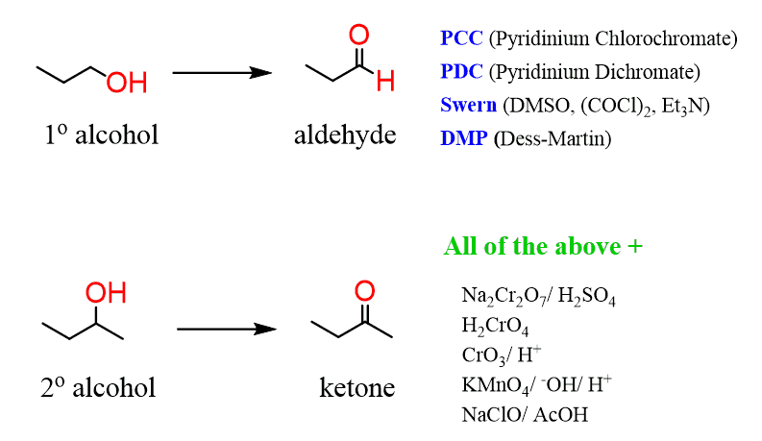
B. 
C. 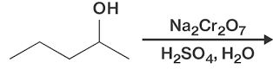
D. None of these
ANSWER: D

